

Smart Pharmacy Management System – Use Case Diagram

- Actors: Customer, Pharmacist, Administrator, Payment Gateway (Secondary).
- Primary Use Cases: Register/Login, Search Medicines, Upload Prescription, Place Order, Verify Prescription, Make Online Payment, Manage Inventory.
- Relationships:
  - Place Order $\rightarrow$ <<include>> $\rightarrow$ Make Online Payment (Payment is required to order).
  - Upload Prescription $\rightarrow$ <<include>> $\rightarrow$ Register/Login (Authentication required).
  - Verify Prescription $\rightarrow$ <<extend>> $\rightarrow$ Place Order (Conditional check for Rx medicines).
- Justification & Rationale: Enforces role-based security by restricting inventory control to administrators and prescription approvals to pharmacists, ensuring regulatory compliance.
- 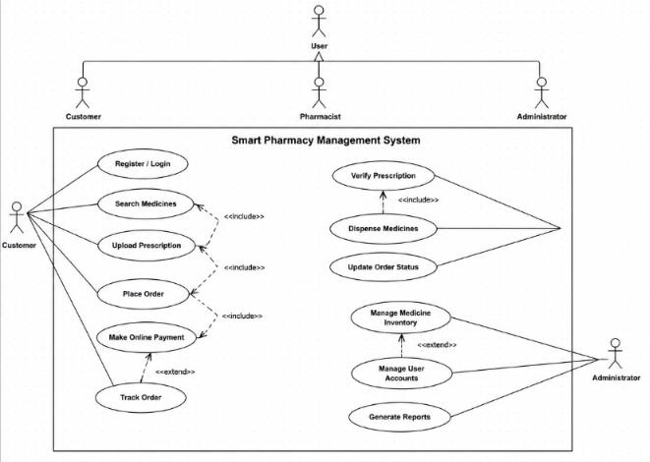

Smart Hotel Management System – Class Diagram

- Classes & Operations: o Guest: -guestId, -name | +makeReservation()
  - Room: -roomNumber, -price, -status | +checkAvailability() o Reservation: -reservationId, -checkInDate | +calculateTotal() o Payment: -paymentId, -amount | +processPayment() o Receptionist: -employeeId | +assignRoom()
- Relationships & Multiplicity: o Composition ($\blackdiamond$): Reservation (1) $\blackdiamond\longleftrightarrow$ (1..*) Payment (Payments cannot exist without a reservation).

  - Aggregation ($\diamond$): Reservation (1..) $\diamond\longleftrightarrow$ (1..) Room (Rooms exist independently of bookings).
  - Association: Guest (1) $\longleftrightarrow$ (0..*) Reservation.
- Justification & Rationale: Decouples transactional data from physical room assets, protecting historical booking records even if room details change.
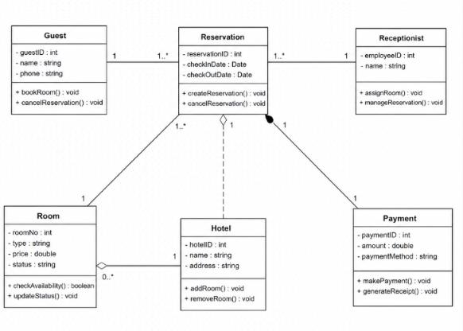

Online Banking System – Sequence Diagram

- Objects
(Lifelines): :Customer, :BankingInterface, :AuthenticationService, :BankingServer, :Database.
- Message Flow:
  - login() $\rightarrow$ :BankingInterface $\rightarrow$ :AuthenticationService. o sendOTP() $\rightarrow$ :AuthenticationService $\rightarrow$ :Customer. o submitOTP() $\rightarrow$ :Customer $\rightarrow$ :AuthenticationService.
  - authSuccess (Dashed Return) $\rightarrow$ :AuthenticationService $\dashrightarrow$ :BankingInterface. o transferFunds() $\rightarrow$ :BankingInterface $\rightarrow$ :BankingServer $\rightarrow$ :Database.
  - confirmTransaction (Dashed Return) $\rightarrow$ :Database
$\dashrightarrow$ :BankingServer $\dashrightarrow$ :Customer.
- Justification & Rationale: Synchronous messaging ensures multi-factor authentication (OTP) must succeed before any core banking database updates occur.
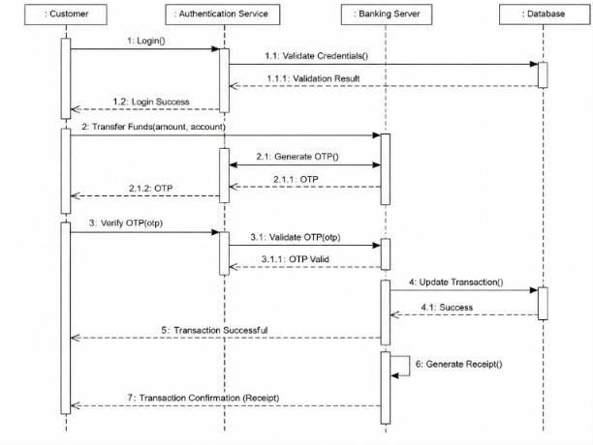

Passport Application System – Activity Diagram

- Key Activities: Submit Application, Upload Documents, Verify Identity, Process Payment, Print Passport, Dispatch Passport.
- Decision Nodes:
  - Node 1: Identity Verified? $\rightarrow$ Yes: Proceed to payment. | No: Reject / Request reupload.
  - Node 2: Payment Success? $\rightarrow$ Yes: Proceed to processing. | No: Display failure error.
- Parallel Processing (Fork & Join): Use a Fork Bar after payment to split into Generate Digital Record and Print Physical Passport concurrently, then a Join Bar before Dispatch Passport.
- Justification & Rationale: Parallel execution optimizes throughput, while decision nodes handle rejection logic without crashing the application flow.
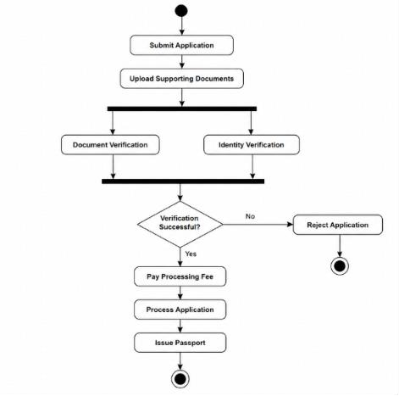

Smart Elevator Control System – State Diagram

- States: Idle, Door Open, Door Closed, Moving Up, Moving Down, Emergency Stop, Maintenance Mode.
- Key Transitions & Triggers:
  - Idle $\rightarrow$ Door Closed (Trigger: Call Button Pressed).
  - Door Closed $\rightarrow$ Moving Up/Down (Trigger: Motor Start [Guard: Target Floor Bar Selected]).
  - Moving $\rightarrow$ Idle (Trigger: Target Floor Reached).
  - Global Transition: Any State $\rightarrow$ Emergency Stop (Trigger: Emergency Switch Activated).
- Justification & Rationale: Global emergency transitions guarantee safety compliance by overriding active operational states immediately upon error detection.
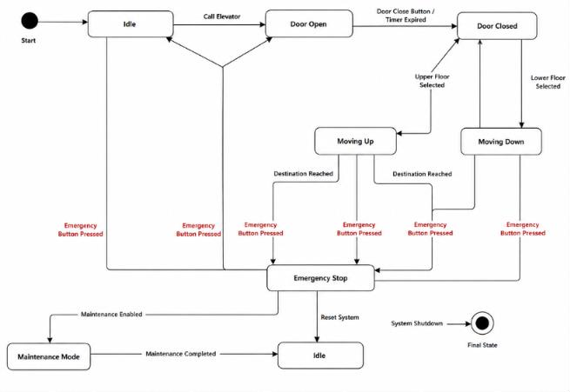

Smart Home Automation System – Deployment Diagram

- Hardware Nodes & Software Artifacts: o Smart Sensor Node $\rightarrow$ Deploys «artifact» SensorFirmware.elf o IoT Home Gateway $\rightarrow$ Deploys «artifact» GatewayMiddleware.jar o Cloud Application Server $\rightarrow$ Deploys «artifact» SmartHomeCloud.war o User Mobile Device $\rightarrow$ Deploys «artifact» SmartHomeApp.apk
- Communication Links & Protocols:
o Sensor Node $\longleftrightarrow$ Gateway: Zigbee / Z-Wave o Gateway $\longleftrightarrow$ Cloud Server: MQTT over TLS o Mobile Device $\longleftrightarrow$ Cloud Server: HTTPS / WebSockets o Mobile Device $\longleftrightarrow$ Gateway (Local Fallback): Local Wi-Fi (REST)
- Justification & Rationale: Including a local Wi-Fi fallback ensures users maintain direct control over smart appliances even during internet outages.
